CHURCH OF THE TRINITY
Coatesville
in the
Episcopal Diocese of Pennsylvania

Church of the Trinity is a congregation
rooted in the faith and love of Christ, unified
in diversity,
seeking to grow and nourish
the Trinity family and our Coatesville community.

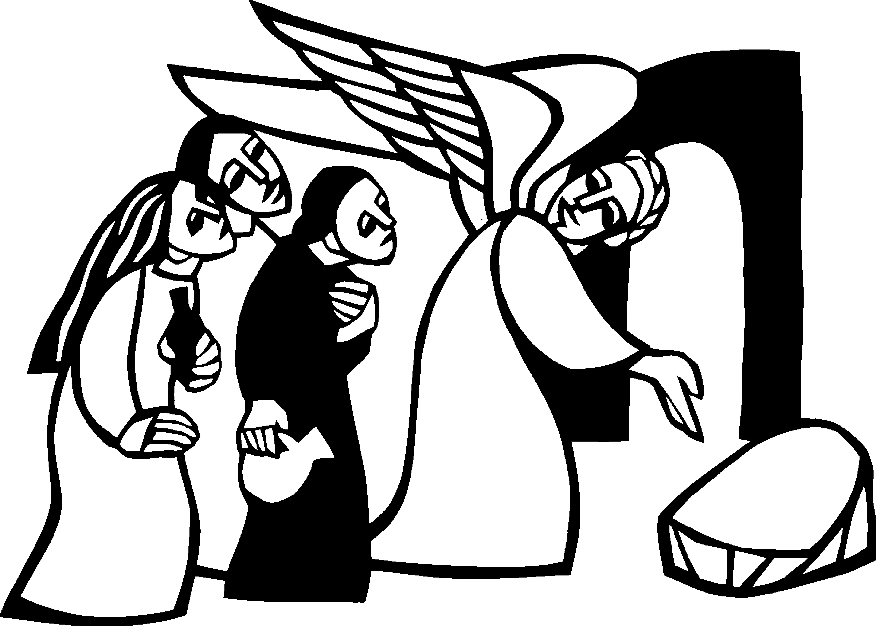

Easter Day
The Holy Eucharist Rite Two
Sunday, April 5, 2026

un-burying of the Alleluia with the parish children With music

The Word of God

Entrance Rite

Entrance Hymn Jesus Christ is risen today (Easter Hymn) (H 207)
Opening Acclamation (BCP p. 355)
The people standing, the Celebrant says
Celebrant | Alleluia. Christ is risen.
People | The Lord is risen indeed. Alleluia.

Collect for Purity (BCP p. 355)
The Celebrant may say
Almighty God, to you all hearts are open, all desires known, and from you no secrets are hid: Cleanse the thoughts of our hearts by the inspiration of your Holy Spirit, that we may perfectly love you, and worthily magnify your holy Name; through Christ our Lord. Amen.

Opening Anthem or Song of Praise S 278 Glory to God (Canticle 20) (Mathias) (BCP p. 356)
The following is sung, all standing
The Collect of the Day (BCP p. 357)
Celebrant | The Lord be with you.
People | And also with you.
Celebrant | Let us pray.

O God, who for our redemption gave your only-begotten Son to the death of the cross, and by his glorious resurrection delivered us from the power of our enemy: Grant us so to die daily to sin, that we may evermore live with him in the joy of his resurrection; through Jesus Christ your Son our Lord, who lives and reigns with you and the Holy Spirit, one God, now and forever. Amen.

The Lessons

First Reading: Acts 10:34-43
The people sit.
A Reading from the Acts of the Apostles.
³⁴Peter began to speak to [Cornelius and the other Gentiles]: “I truly understand that God shows no partiality, ³⁵but in every nation anyone who fears him and does what is right is acceptable to him. ³⁶You know the message he sent to the people of Israel, preaching peace by Jesus Christ—he is Lord of all. ³⁷That message spread throughout Judea, beginning in Galilee after the baptism that John announced: ³⁸how God anointed Jesus of Nazareth with the Holy Spirit and with power; how he went about doing good and healing all who were oppressed by the devil, for God was with him. ³⁹We are witnesses to all that he did both in Judea and in Jerusalem. They put him to death by hanging him on a tree; ⁴⁰but God raised him on the third day and allowed him to appear, ⁴¹not to all the people but to us who were chosen by God as witnesses, and who ate and drank with him after he rose from the dead. ⁴²He commanded us to preach to the people and to testify that he is the one ordained by God as judge of the living and the dead. ⁴³All the prophets testify about him that everyone who believes in him receives forgiveness of sins through his name.”

Reader | The Word of the Lord.
People | Thanks be to God.

Psalm: Psalm 118:1-2, 14-24
Remain seated.
¹Give thanks to the Lord, for he is good; *
his mercy endures forever.
²Let Israel now proclaim, *
“His mercy endures forever.”
¹⁴The Lord is my strength and my song, *
and he has become my salvation.
¹⁵There is a sound of exultation and victory *
in the tents of the righteous:
¹⁶“The right hand of the Lord has triumphed! *
The right hand of the Lord is exalted!
The right hand of the Lord has triumphed!”
¹⁷I shall not die, but live, *
and declare the works of the Lord.
¹⁸The Lord has punished me sorely, *
but he did not hand me over to death.
¹⁹Open for me the gates of righteousness; *
I will enter them;
I will offer thanks to the Lord.
²⁰“This is the gate of the Lord; *
he who is righteous may enter.”
²¹I will give thanks to you, for you answered me *
and have become my salvation.
²²The same stone which the builders rejected *
has become the chief cornerstone.
²³This is the Lord’s doing, *
and it is marvelous in our eyes.
²⁴On this day the Lord has acted; *
we will rejoice and be glad in it.

Second Reading: Colossians 3:1-4
The people sit.
A Reading from Paul's letter to the Church in Colossus.
¹[Since] you have been raised with Christ, seek the things that are above, where Christ is, seated at the right hand of God.²Set your minds on things that are above, not on things that are on earth, ³for you have died, and your life is hidden with Christ in God. ⁴When Christ who is your life is revealed, then you also will be revealed with him in glory.

Reader | The Word of the Lord.
People | Thanks be to God.

Gospel Acclamation
All stand.
Halle, halle, hallelujah!
Halle, halle, hallelujah!
Halle, halle, hallelujah!
Hallelujah! Hallelujah!

Gospel: Matthew 28: 1-10
All stand.
Priest | The Holy Gospel of our Lord Jesus Christ according to Matthew.
People | Glory to you, Lord Christ.

¹After the sabbath, as the first day of the week was dawning, Mary Magdalene and the other Mary went to see the tomb. ²And suddenly there was a great earthquake; for an angel of the Lord, descending from heaven, came and rolled back the stone and sat on it. ³His appearance was like lightning, and his clothing white as snow. ⁴For fear of him the guards shook and became like dead men. ⁵But the angel said to the women, “Do not be afraid; I know that you are looking for Jesus who was crucified. ⁶He is not here; for he has been raised, as he said. Come, see the place where he lay. ⁷Then go quickly and tell his disciples, ‘He has been raised from the dead, and indeed he is going ahead of you to Galilee; there you will see him.’ This is my message for you.” ⁸So they left the tomb quickly with fear and great joy, and ran to tell his disciples. ⁹Suddenly Jesus met them and said, “Greetings!” And they came to him, took hold of his feet, and worshiped him. ¹⁰Then Jesus said to them, “Do not be afraid; go and tell my brothers to go to Galilee; there they will see me.”

Priest | The Gospel of the Lord.
People | Praise to you, Lord Christ.

The Sermon and CHILDREN’S SERMON by the Rev. Kristen Ostendorf (BCP p. 358)

The Creed (BCP p. 358)
All stand.
We believe in one God,
the Father, the Almighty,
maker of heaven and earth,
of all that is, seen and unseen.
We believe in one Lord, Jesus Christ,
the only Son of God,
eternally begotten of the Father,
God from God, Light from Light,
true God from true God,
begotten, not made,
of one Being with the Father.
Through him all things were made.
For us and for our salvation
he came down from heaven:
by the power of the Holy Spirit
he became incarnate from the Virgin Mary,
and was made man.
For our sake he was crucified under Pontius Pilate;
he suffered death and was buried.
On the third day he rose again
in accordance with the Scriptures;
he ascended into heaven
and is seated at the right hand of the Father.
He will come again in glory to judge the living and the dead,
and his kingdom will have no end.
We believe in the Holy Spirit, the Lord, the giver of life,
who proceeds from the Father and the Son.
With the Father and the Son he is worshiped and glorified.
He has spoken through the Prophets.
We believe in one holy catholic and apostolic Church.
We acknowledge one baptism for the forgiveness of sins.
We look for the resurrection of the dead,
and the life of the world to come. Amen.

The Prayers of the People (BCP p. 359)
All remain standing.
The Leader and People pray responsively
In peace, we pray to you, Lord God.
Silence
For all people in their daily life and work;
For our families, friends, and neighbors, and for those who are alone.
For this community, the nation, and the world; we remember especially the people of Iran, the Holy Land, Ukraine, Cuba, Venezuela, the Sudan and Haiti;
For all who work for justice, freedom, and peace.
For the just and proper use of your creation;
For the victims of hunger, fear, injustice, and oppression.
For all who are in danger, sorrow, or any kind of trouble;
For those who minister to the sick, the friendless, and the needy.
For the peace and unity of the Church of God;
For all who proclaim the Gospel, and all who seek the Truth.
For all bishops and other ministers;
For all who serve God in his Church.
For the special needs and concerns of this congregation. We remember those on our parish prayer list and those who have sought private prayers from our prayer chain ministry.
Silence
The People may add their own petitions
Hear us, Lord;
For your mercy is great.
We thank you, Lord, for all the blessings of this life. We give thanks for those on our first responders and military list, as well as those celebrating birthdays and anniversaries this week, including Sherry Deets, Diane Evans, Stacey Heston, James O. Gaddy Jr., and Alfred Carey Jr.
Silence
The People may add their own thanksgivings
We will exalt you, O God our King;
And praise your Name for ever and ever.
We pray for all who have died, that they may have a place in your eternal kingdom. We remember those for whom flowers were given in their honor this Easter season, as well as William and Lois Batteiger, and Rufus and Stella Batteiger, for whom the altar arrangements were given.
Silence
The People may add their own petitions
Lord, let your loving-kindness be upon them;
Who put their trust in you.
We pray to you also for the forgiveness of our sins.
Silence may be kept.
Leader and People
Have mercy upon us, most merciful Father; in your compassion forgive us our sins, known and unknown, things done and left undone; and so uphold us by your Spirit that we may live and serve you in newness of life, to the honor and glory of your Name; through Jesus Christ our Lord. Amen.
The priest says
Almighty God have mercy on you, forgive you all your sins through our Lord Jesus Christ, strengthen you in all goodness, and by the power of the Holy Spirit keep you in eternal life. Amen.

The Peace (BCP p. 360)
All stand.
Celebrant | The peace of the Lord be always with you.
People | And also with you.

Then the Ministers and the People may greet one another in the name of the Lord.

The Holy Communion

THe offertory sentence

Offertory Hymn In the garden (LEVAS 69)
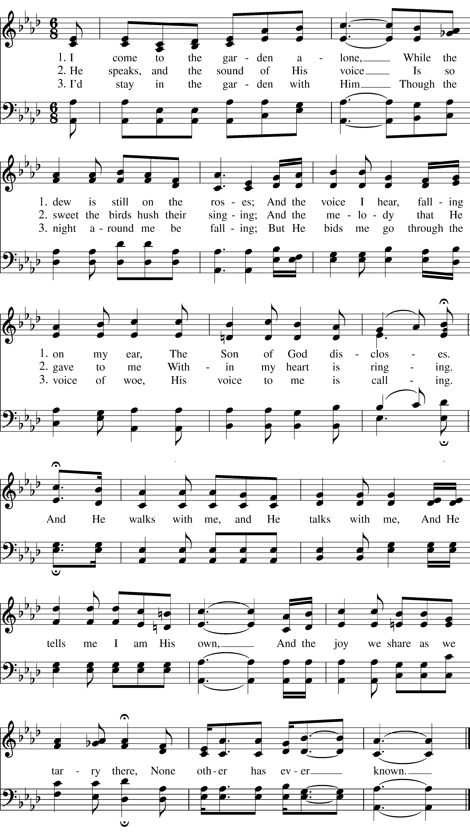

The Great Thanksgiving

Sursum Corda
The People remain standing.
Presider | The Lord be with you.
People | And also with you.
Presider | Lift up your hearts.
People | We lift them to the Lord.
Presider | Let us give thanks to the Lord our God.
People | It is right to give our thanks and praise.

Proper Preface (BCP p. 373)
It is truly right to glorify you, Father, and to give you thanks; for you alone are God, living and true, dwelling in light inaccessible from before time and forever.
Fountain of life and source of all goodness, you made all things and fill them with your blessing; you created them to rejoice in the splendor of your radiance.
Countless throngs of angels stand before you to serve you night and day; and, beholding the glory of your presence, they offer you unceasing praise. Joining with them, and giving voice to every creature under heaven, we acclaim you, and glorify your Name, as we say,

SANCTUS S 125 Holy, holy, holy (Proulx) (BCP p. 362)
Presider and People
Holy, holy, holy Lord, God of power and might, heaven and earth are full of your glory. Hosanna in the highest. Blessed is he who comes in the name of the Lord. Hosanna in the highest.

Words of Institution (BCP p. 373)
The Celebrant continues
We acclaim you, holy Lord, glorious in power. Your mighty works reveal your wisdom and love. You formed us in your own image, giving the whole world into our care, so that, in obedience to you, our Creator, we might rule and serve all your creatures. When our disobedience took us far from you, you did not abandon us to the power of death. In your mercy you came to our help, so that in seeking you we might find you. Again and again you called us into covenant with you, and through the prophets you taught us to hope for salvation.
Father, you loved the world so much that in the fullness of time you sent your only Son to be our Savior. Incarnate by the Holy Spirit, born of the Virgin Mary, he lived as one of us, yet without sin. To the poor he proclaimed the good news of salvation; to prisoners, freedom; to the sorrowful, joy. To fulfill your purpose he gave himself up to death; and, rising from the grave, destroyed death, and made the whole creation new.
And, that we might live no longer for ourselves, but for him who died and rose for us, he sent the Holy Spirit, his own first gift for those who believe, to complete his work in the world, and to bring to fulfillment the sanctification of all.
When the hour had come for him to be glorified by you, his heavenly Father, having loved his own who were in the world, he loved them to the end; at supper with them he took bread, and when he had given thanks to you, he broke it, and gave it to his disciples, and said, “Take, eat: This is my Body, which is given for you. Do this for the remembrance of me.”
After supper he took the cup of wine; and when he had given thanks, he gave it to them, and said, “Drink this, all of you. This is my Blood of the new Covenant, which is shed for you and for many for the forgiveness of sins. Whenever you drink it, do this for the remembrance of me.”
Father, we now celebrate this memorial of our redemption. Recalling Christ’s death and his descent among the dead, proclaiming his resurrection and ascension to your right hand, awaiting his coming in glory; and offering to you, from the gifts you have given us, this bread and this cup, we praise you and we bless you.
Celebrant and People
We praise you, we bless you, we give thanks to you, and we pray to you, Lord our God.
Epiclesis (BCP p. 375)
The Celebrant continues
Lord, we pray that in your goodness and mercy your Holy Spirit may descend upon us, and upon these gifts, sanctifying them and showing them to be holy gifts for your holy people, the bread of life and the cup of salvation, the Body and Blood of your Son Jesus Christ.
Grant that all who share this bread and cup may become one body and one spirit, a living sacrifice in Christ, to the praise of your Name.
Remember, Lord, your one holy catholic and apostolic Church, redeemed by the blood of your Christ. Reveal its unity, guard its faith, and preserve it in peace.
And grant that we may find our inheritance with all the saints who have found favor with you in ages past. We praise you in union with them and give you glory through your Son Jesus Christ our Lord.
Through Christ, and with Christ, and in Christ, all honor and glory are yours, Almighty God and Father, in the unity of the Holy Spirit, for ever and ever. AMEN

The Lord’s Prayer
(LEVAS #264)
As our Savior Christ has taught us, we now sing,
People and Celebrant
Our Father, which art in heaven, hallowed be thy Name, thy kingdom come, thy will be done, on earth as it is in heaven. Give us this day our daily bread. And forgive us our debts as we forgive our debtors. And lead us not into temptation, but deliver us from evil. For thine is the kingdom, and the power, and the glory, forever. Amen.

The Breaking of the Bread

Fraction Anthem (BCP p. 364)

Alleluia. Christ our Passover is sacrificed for us; Therefore let us keep the feast. Alleluia.

Invitation (BCP p. 364)
The Celebrant says
The Gifts of God for the People of God. Take them in remembrance that Christ died for you, and feed on him in your hearts by faith, with thanksgiving.
All people are welcome at God’s table. We invite all baptized Christians – regardless of your denomination – to partake in holy communion. Communion may be received in both kinds – bread and wine – or just one. Gluten free hosts are available. If you are not receiving communion today, please cross your hands over your chest and Rev. Kristen will offer you a blessing. If you are interested in baptism, please let Rev. Kristen know!
Communion Hymn This Is The Day (LEVAS 219)
POST COMMUNION ANTHEM
Post-Communion Prayer (BCP p. 365)
After Communion, the Celebrant says
Let us pray.
Celebrant and People
Loving God, we give you thanks for restoring us in your image and nourishing us with spiritual food in the Sacrament of Christ’s Body and Blood. Now send us forth a people, forgiven, healed, renewed; that we may proclaim your love to the world and continue in the risen life of Christ our Savior. Amen.

Blessing (BCP p. 366)

Post-Communion Hymn He is risen, He is risen (H180)
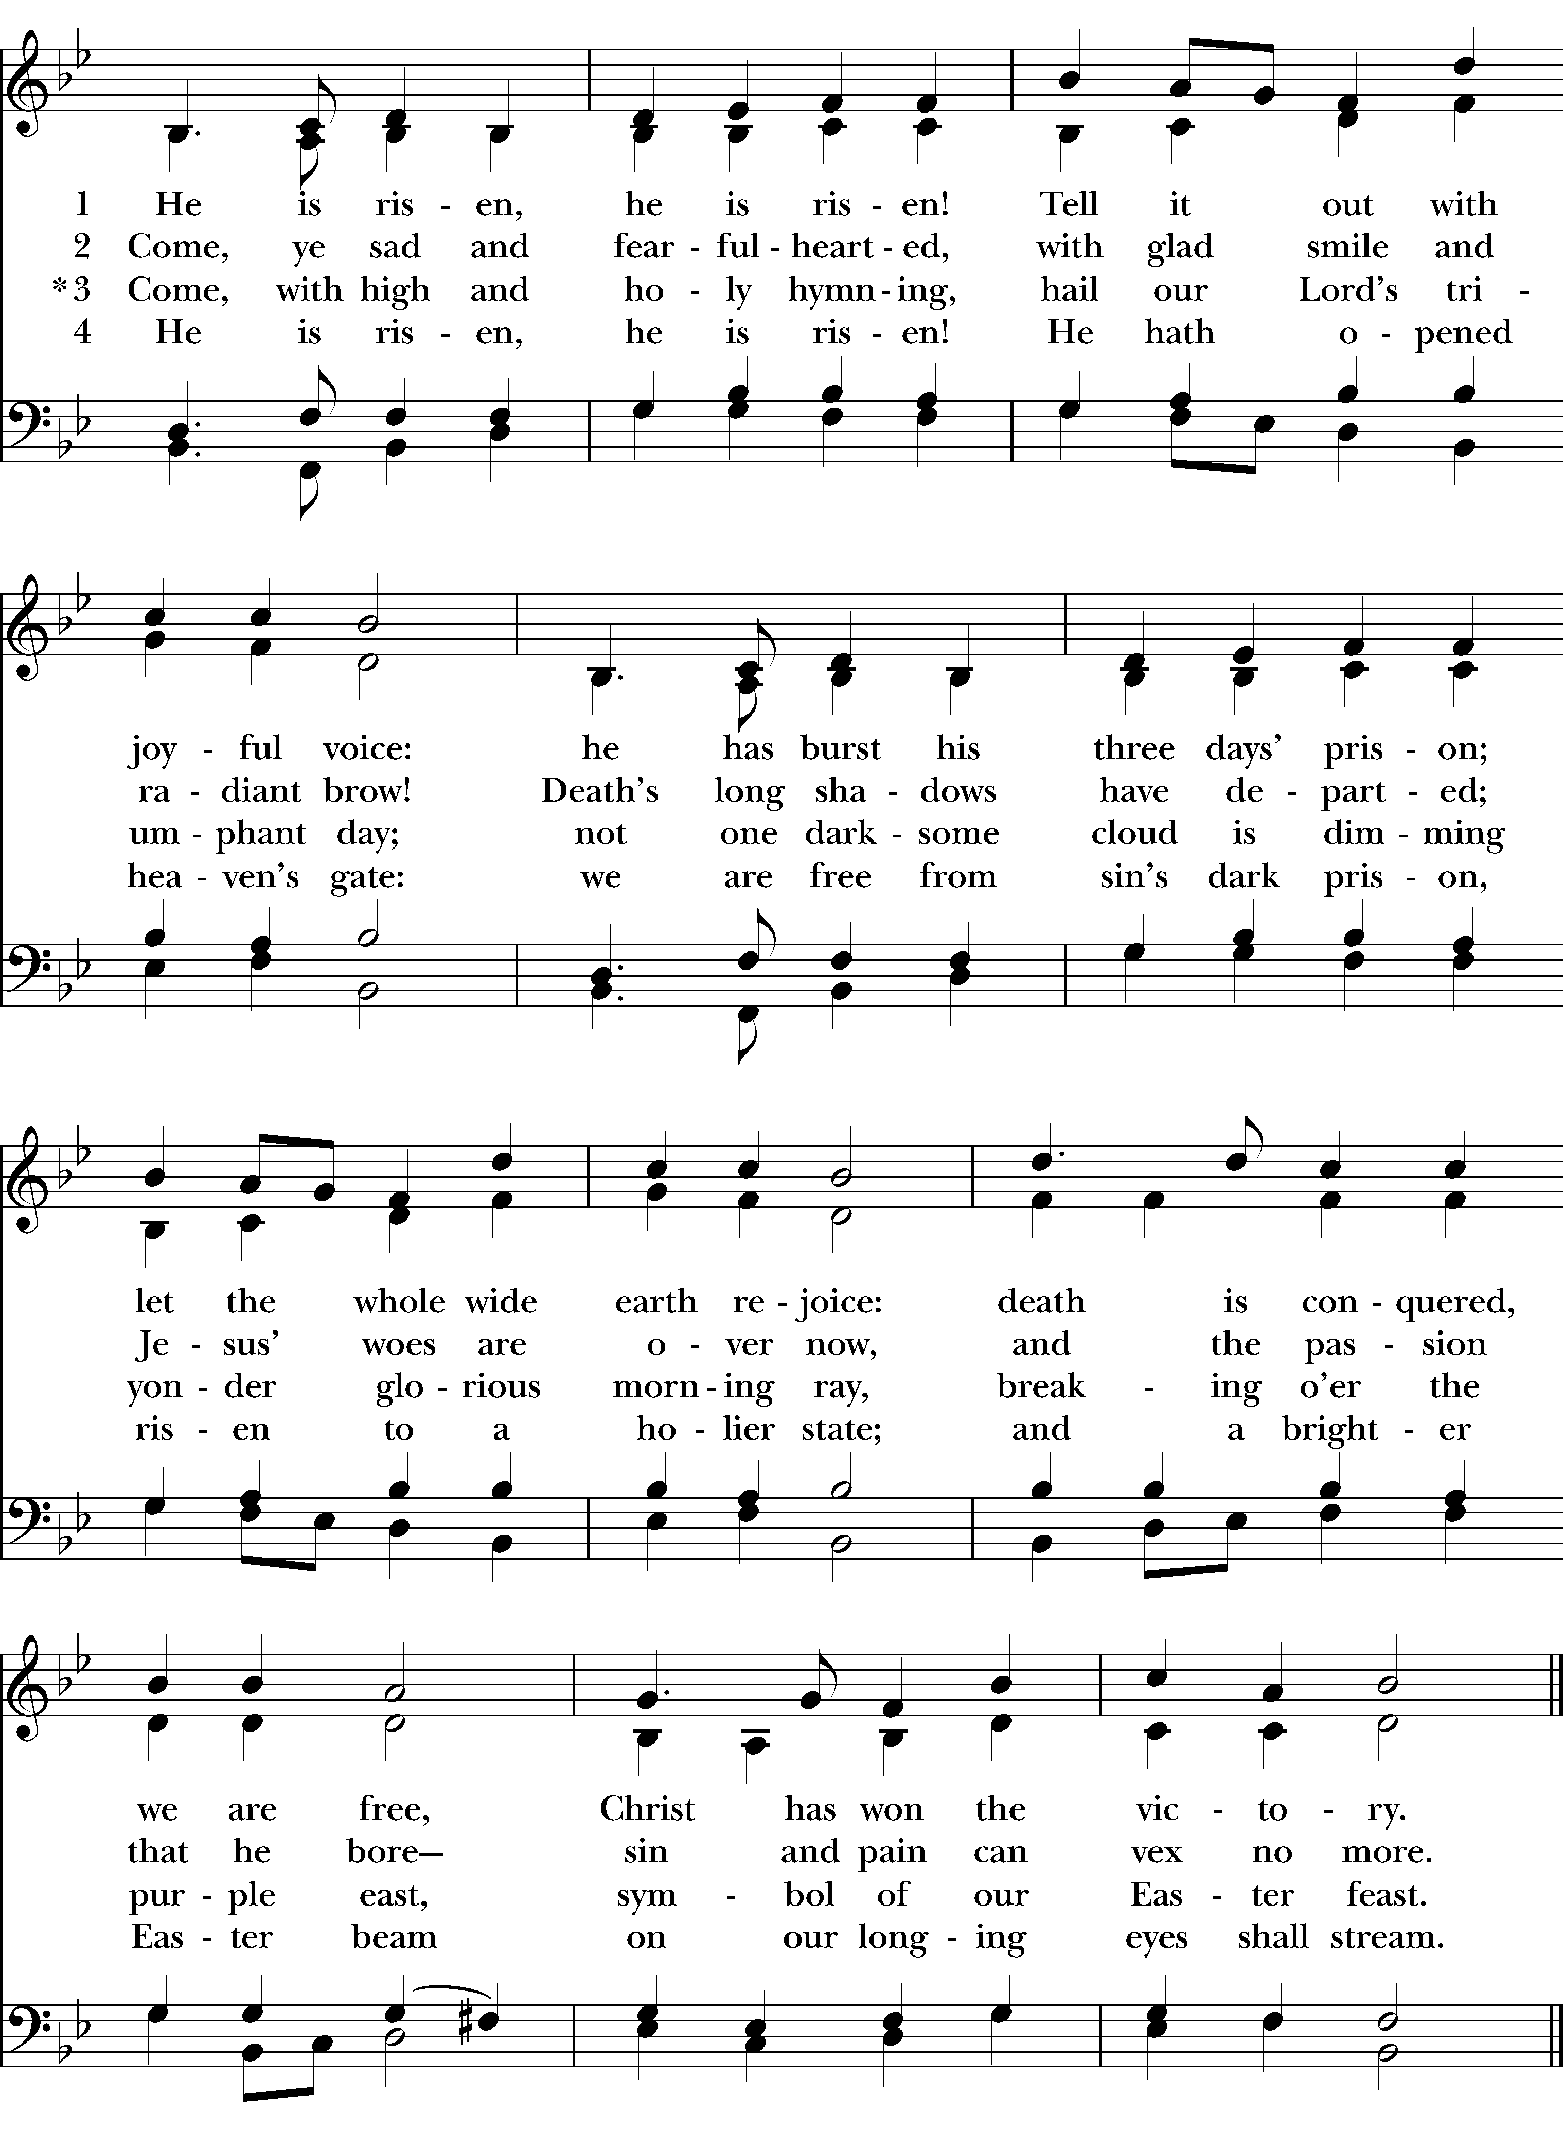
Dismissal (BCP p. 366)
 | Let us go forth in the name of Christ. Alleluia, alleluia.
People | Thanks be to God. Alleluia, alleluia.  Please remain seated for our postlude and join us for the Easter egg hunt. Kids will meet with Rev. Kristen before heading out to find the eggs!  Special thanks to cellist Lauren Blackwell.

The flowers are placed on the altar to the Glory of God
and in Loving Memory of

William & Lois Batteiger and Rufus & Stella Batteiger
By Carl & Miranda Croft

WANT PRAYER? Our prayer chain is ready! Place your request in the basket using the form on the credenza by the baptismal font. Give as little or as much information as you want: It is confidential.

Got time? We are looking to set up a rotation of regular volunteer receptionists. This crew of volunteers would answer the phone and let in parishioners seeking private prayer time in the sanctuary. They also may be asked to do some light administrative tasks (or just enjoy the quiet of the office). Please see Kristen if you can make a regular commitment. Got some time but not a lot? Sign up to be a “task rabbit” at coffee hour: These are small tasks that need doing around the church with a limited time commitment.

Regular CYWA food bank commitment: See Kent N. if you would like to be part of our small but regular volunteer crew every other work at the CYWA. Our next commitment is on April 16.

Taking care of Business: Take care of your business on April 19. We will have Episcopal Legal Aid here for free estate planning (wills) and the NAACP to help ensure you are registered to vote. Did you know that our Book of Common Prayer talks about the importance of wills? Did you know that the NAACP is a non-partisan group that can provide you with voter registration materials? Join us!

Step/Sanctuary Sit and Tide Over Pantry: Did you know we need about 200 items a week for our tide over pantry? Can you help re-stock or sit in the sanctuary to meet the neighbors? It’s easy, and a great way to serve our community. Ongoing needs: Items for Tide Over Pantry (shelf stable “complete” meals, shelf stable milk, bread, PB&J, cereal, canned meats and fish, hygiene items); clothes washing from our basement stock.

Help welcome representatives from the Church Farm School on April 26. Get to know more about this boarding school for young men in the Episcopal tradition, many of whom would not have the opportunities for a college prep experience, practically in our backyard!

Upcoming Trinity Dates: Mark your calendars!
Monday: OFFICE CLOSED, No Bible Study this week!
Thursday: Healing Service at noon on Zoom. Link emailed Wednesday evening.
April 19: Vestry meeting, estate planning clinic, Rev. Cn. Jane Gober, guest preacher
April 26: Church Farm School visits: Come learn about this incredible boarding school for young men in the Episcopal tradition at coffee hour
April 27: Garden clean up and dinner with Coatesville Kids to College, 4-7 p.m.

Please pray for those on our parish prayer list.
Violet Armstead, Angie Ashe, Bob Austin, Molly Baldwin, Marsha Barley, Bill Besecker, Marie Hyacinthe Bribal, Anthony Brogan, Walter Bryant, Millie Connor, Andrea Dudle, Ellie, Charles Emmett, Diane Evans, Marshall Evans, Morris Ferguson, Karen Fisher, Cassie Foreman, Kyla Foreman, Jacob Furlong, Ken Furlong, Phillip Geliebter, Bianca Giannotti, Linda Graber, Samantha Griggs, Susan Hanft, Scott Hansberry, Esther Harvey, Jill Hayes, Pat Hendricks, Matt Hess, Danyell Jackson, Jennifer Jenkins, John and Lindsay, Lisa Kivett, Sye Lamar, Melanie Lifer, Olivia Lyons, Joseph Manni, Paige McLean, Kevin McGloon, Brian Miller, Tracy Mulligan, Bruce Murray, Adam Nolt, Jessica Nupponen, Barbara Oxenreider, Steve Padosh, Stan Pernsley, April Phillips, Ben Phillips, Lynn Pullman, Arlene Purnsley, Michael Rayner, Jacob Rockoff, Thomas Shanley, Barb Smelter, John Smelter, Stephen Smelter, Stephanie, Becky Swaggart, Sean, Dihona Talton and children, Mike Tisbe, Catherine Thompson, Vicki Romberger, Norman Walters, Cyndi Walters, Isaac Warnick, Sally Warren, Paul Wayne, Mary Nell Weiss, Chanel Wiest, Brendan Willauer, Ruby Williams, The Hillview Community

And please pray for our first responders and those who serve in the military
Police: Lt Lori and Jeff Kistle, Military: Skylar Dantzler, MAJ Alex Deets, PO William Dowling, 1st LT Frank
Furman,Jr., J. Andrew Hinkle, SMSgt Rewa Miller, Sgt Kaleel Pernsley, Specialist Jason Sage, COL Jeremy Smith, CMDR Michael Sracic MD, SPC John Starrett

EPISCOPAL CHURCH OF THE TRINITY
323 East Lincoln Highway
Coatesville, Pennsylvania 19320
610-384-4771
Office Email: Trinitycoates@aol.com
Website: www.trinitycoatesville.org

Office Hours:
Monday-Thursday
Friday: Office Closed

Priest in Charge: The Rev. Kristen Ostendorf 908-489-1452 (kristen.ostendorf77@gmail.com) Organist and Choirmaster: Rachel Lee Anemone
Parish Administrator: Jamoca Harkins 610-384-4771 (trinitycoates@aol.com)
Community Engagement Coordinator: Liz Hulse (liztrinity323@gmail.com)

LEADERSHIP TEAM and VESTRY
Sr. Warden: Chris Haak
Treasurer: Minnie Kirwin
Jr. Warden: Joe Lee

Pat Bush, Al Carey, Violet Cole, Bill Gray, Stacey Heston,
Greg Kinsch, Joseph Kirkner, Kent Nation, Vic Shanley,
Betty Sullivan, Michael Thompson

