Church of the Holy Trinity
Coatesville
in the Episcopal Diocese of Pennsylvania

Church of the Trinity is a congregation rooted in the faith and love of Christ, unified in diversity, seeking to grow and nourish the Trinity family and our Coatesville community.

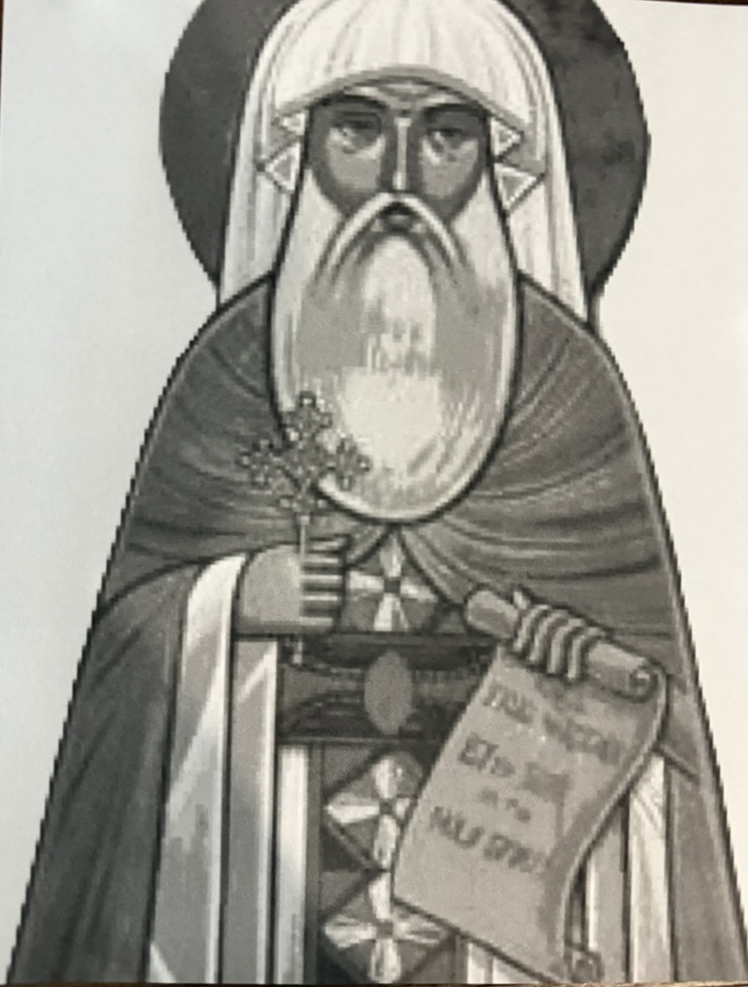

The Feast of St. Cyril of Alexandria
The Holy Eucharist Rite Two
Sunday, June 28, 2026

PRELUDE
Entrance Rite

entrance Hymn Come Thou Font of Every Blessing (LEVAS 111)

Opening Acclamation (BCP p. 355)
The people standing, the Celebrant says
 | Blessed be God: Father, Son, and Holy Spirit.
People | And blessed be his kingdom, now and forever. Amen.

Collect for Purity
The Celebrant may say
Almighty God, to you all hearts are open, all desires known, and from you no secrets are hid: Cleanse the thoughts of our hearts by the inspiration of your Holy Spirit, that we may perfectly love you, and worthily magnify your holy Name; through Christ our Lord. Amen.

Song of Praise S 278 Glory to God (Canticle 20) (Mathias) (BCP p. 356)
The following is sung, all standing

The Collect of the Day (BCP p. 357)
Celebrant | The Lord be with you.
People | And also with you.
Celebrant | Let us pray.
Heavenly Father, whose servant Cyril steadfastly proclaimed your Son Jesus Christ to be one person, fully God and fully man: Keep us, we pray, constant in this faith and worship; through Jesus Christ our Lord, who lives and reigns with you and the Holy Spirit, one God, for ever and ever. Amen.
The Lessons

First Reading: Wisdom 7:7-14
The people sit.
A Reading from the book of Wisdom.
⁷Therefore I prayed, and understanding was given me;
I called on God, and the spirit of wisdom came to me.
⁸I preferred her to scepters and thrones,
and I accounted wealth as nothing in comparison with her.
⁹Neither did I liken to her any priceless gem,
because all gold is but a little sand in her sight,
and silver will be accounted as clay before her.
¹⁰I loved her more than health and beauty,
and I chose to have her rather than light,
because her radiance never ceases.
¹¹All good things came to me along with her,
and in her hands uncounted wealth.
¹²I rejoiced in them all, because wisdom leads them;
but I did not know that she was their mother.
¹³I learned without guile and I impart without grudging;
I do not hide her wealth,
¹⁴for it is an unfailing treasure for mortals;
those who get it obtain friendship with God,
commended for the gifts that come from instruction.

Reader | The Word of the Lord.
People | Thanks be to God.

Psalm: Psalm 119:97-104
Remain seated.
⁹⁷Oh, how I love your law!
It is my meditation all day long.
⁹⁸Your commandment makes me wiser than my enemies,
for it is always with me.
⁹⁹I have more understanding than all my teachers,
for your decrees are my meditation.
¹⁰⁰I understand more than the aged,
for I keep your precepts.
¹⁰¹I hold back my feet from every evil way,
in order to keep your word.
¹⁰²I do not turn away from your ordinances,
for you have taught me.
¹⁰³How sweet are your words to my taste,
sweeter than honey to my mouth!
¹⁰⁴Through your precepts I get understanding;
therefore I hate every false way.
Second Reading: 1 Corinthians 2:10,13-16
A Reading from Paul's First letter to the Church in Corinth.
¹⁰These things God has revealed to us through the Spirit; for the Spirit searches everything, even the depths of God. ¹³And we speak of these things in words not taught by human wisdom but taught by the Spirit, interpreting spiritual things to those who are spiritual.
¹⁴Those who are unspiritual do not receive the gifts of God's Spirit, for they are foolishness to them, and they are unable to understand them because they are spiritually discerned. ¹⁵Those who are spiritual discern all things, and they are themselves subject to no one else's scrutiny.

¹⁶"For who has known the mind of the Lord
so as to instruct him?"
But we have the mind of Christ.

Reader | The Word of the Lord.
People | Thanks be to God.

GOSPEL ACCLAMATION (BCP p. 357)
All stand.
Halle, halle, hallelujah!
Halle, halle, hallelujah!
Halle, halle, hallelujah!
Hallelujah! Hallelujah!

Gospel: John 17:18-23
All stand.
Priest | The Holy Gospel of our Lord Jesus Christ according to John.
People | Glory to you, Lord Christ.

¹⁸As you have sent me into the world, so I have sent them into the world. ¹⁹And for their sakes I sanctify myself, so that they also may be sanctified in truth.
²⁰I ask not only on behalf of these, but also on behalf of those who will believe in me through their word, ²¹that they may all be one. As you, Father, are in me and I am in you, may they also be in us, so that the world may believe that you have sent me. ²²The glory that you have given me I have given them, so that they may be one, as we are one, ²³I in them and you in me, that they may become completely one, so that the world may know that you have sent me and have loved them even as you have loved me.

Priest | The Gospel of the Lord.
People | Praise to you, Lord Christ.

Sermon by the Rev. Elisa King,
St. Paul's African Methodist EPISCOPAL Church, Coatesville

The Creed (BCP p. 358)
All stand.
We believe in one God,
the Father, the Almighty,
maker of heaven and earth,
of all that is, seen and unseen.
We believe in one Lord, Jesus Christ,
the only Son of God,
eternally begotten of the Father,
God from God, Light from Light,
true God from true God,
begotten, not made,
of one Being with the Father.
Through him all things were made.
For us and for our salvation
he came down from heaven:
by the power of the Holy Spirit
he became incarnate from the Virgin Mary,
and was made man.
For our sake he was crucified under Pontius Pilate;
he suffered death and was buried.
On the third day he rose again
in accordance with the Scriptures;
he ascended into heaven
and is seated at the right hand of the Father.
He will come again in glory to judge the living and the dead,
and his kingdom will have no end.
We believe in the Holy Spirit, the Lord, the giver of life,
who proceeds from the Father and the Son.
With the Father and the Son he is worshiped and glorified.
He has spoken through the Prophets.
We believe in one holy catholic and apostolic Church.
We acknowledge one baptism for the forgiveness of sins.
We look for the resurrection of the dead,
and the life of the world to come. Amen.

The Prayers of the People (BCP p. 359)
All remain standing.
I ask your prayers for God’s people throughout the world; for our Presiding Bishop Sean and our Bishop Daniel; for this gathering; and for all ministers and people.
Pray for the Church.
Silence
I ask your prayers for peace; for goodwill among nations; and for the well-being of all people.
Pray for justice and peace.
Silence
I ask your prayers for the poor, the sick, the hungry, the oppressed, and those in prison.
Pray for those in any need or trouble.
Silence
I ask your prayers for all who seek God, or a deeper knowledge of him.
Pray that they may find and be found by him.
Silence
I ask your prayers for the departed. We remember xxx, Godfather of Mary Davis, who died recently.
Pray for those who have died.
Silence
Members of the congregation may ask the prayers or the thanksgivings of those present
Silence.
I ask your prayers for those on our parish prayer list, our military and first responder list, and those being prayed for privately by our prayer chain ministry.
I ask your prayers of thanksgiving for the ministry of and fellowship with St. Paul’s African Methodist Episcopal Church, and their pastor, the Rev. Elisa King. We also give thanks for Kimberly Stauffer, who celebrates her birthday this week, and Lance and Jezel Bush, who celebrate their anniversary this month. I also ask your prayers for recent graduates, including Sam Haak and Abigail Guidi.
Silence
Praise God for those in every generation in whom Christ has been honored. We remember especially Myrtle Kirkner, for whom the altar flowers are given. Pray that we may have grace to glorify Christ in our own day.
Silence

The Celebrant adds a concluding Collect.

Confession of Sin (BCP p. 359)
The Deacon or Celebrant says
Let us confess our sins against God and our neighbor.
Silence may be kept.
Minister and People
Most merciful God,
we confess that we have sinned against you
in thought, word, and deed,
by what we have done,
and by what we have left undone.
We have not loved you with our whole heart;
we have not loved our neighbors as ourselves.
We are truly sorry and we humbly repent.
For the sake of your Son Jesus Christ,
have mercy on us and forgive us;
that we may delight in your will,
and walk in your ways,
to the glory of your Name. Amen.
The Priest stands and says
Almighty God have mercy on you, forgive you all your sins through our Lord Jesus Christ, strengthen you in all goodness, and by the power of the Holy Spirit keep you in eternal life. Amen.
The Peace (BCP p. 360)
All stand.
Celebrant | The peace of the Lord be always with you.
People | And also with you.

Then the Ministers and the People may greet one another in the name of the Lord.

The Holy Communion

Offertory Sentence (BCP p. 376)

Offertory Hymn Amazing Grace (LEVAS 181)

The Great Thanksgiving

Sursum Corda
The People remain standing.
Celebrant | The Lord be with you.
People | And also with you.
Celebrant | Lift up your hearts.
People | We lift them to the Lord.
Celebrant | Let us give thanks to the Lord our God.
People | It is right to give our thanks and praise.

Proper Preface
Celebrant | It is truly right, and good and joyful, to give you thanks, all-holy God, source of life and fountain of mercy.
Because in the obedience of your saints you have given us an example of righteousness, and in their eternal joy a glorious pledge of the hope of our calling.
Therefore, joining with Angels and Archangels and with the faithful of every generation, we lift our voices with all creation as we sing:
SANCTUS S125 (Proulx) BCP p. 362
Celebrant and people
Holy, holy, holy Lord, God of power and might, heaven and earth are full of your glory.
Hosanna in the highest. Blessed is the one who comes in the name of the Lord. Hosanna in the highest, hosanna in the highest.

Words of Institution
The Celebrant continues
Holy and gracious Father: In your infinite love you made us
for yourself, and, when we had fallen into sin and become
subject to evil and death, you, in your mercy, sent Jesus
Christ, your only and eternal Son, to share our human
nature, to live and die as one of us, to reconcile us to you, the
God and Father of all.
He stretched out his arms upon the cross, and offered himself,
in obedience to your will, a perfect sacrifice for the whole
world.
On the night he was handed over to suffering and death, our
Lord Jesus Christ took bread; and when he had given thanks
to you, he broke it, and gave it to his disciples, and said, "Take,
eat: This is my Body, which is given for you. Do this for the
remembrance of me.
After supper he took the cup of wine; and when he had given
thanks, he gave it to them, and said, "Drink this, all of you:
This is my Blood of the new Covenant, which is shed for you
and for many for the forgiveness of sins. Whenever you drink
it, do this for the remembrance of me."
Celebrant and People
Christ has died.
Christ is risen.
Christ will come again
Epiclesis
The Celebrant continues
We celebrate the memorial of our redemption, O Father, in
this sacrifice of praise and thanksgiving. Recalling his death,
resurrection, and ascension, we offer you these gifts.
Sanctify them by your Holy Spirit to be for your people the
Body and Blood of your Son, the holy food and drink of new
and unending life in him. Sanctify us also that we may faithfully
receive this holy Sacrament, and serve you in unity, constancy,
and peace; and at the last day bring us with all your saints
into the joy of your eternal kingdom.
All this we ask through your Son Jesus Christ: By him, and
with him, and in him, in the unity of the Holy Spirit all honor
and glory is yours, Almighty Father, now and forever. AMEN
The Lord’s Prayer
And now, as our Savior Christ has taught us, we are bold to sing,
People and Celebrant
Our Father, which art in heaven, hallowed by thy name. Thy kingdom come. Thy will be done on earth as it is in heaven. Give us this day our daily bread. And forgive us our debts as we forgive our debtors. And lead us not into temptation but deliver us from evil. For thine is the kingdom, and the power and the glory, forever. Amen.

The Breaking of the Bread

Fraction Anthem (BCP p. 364)
Alleluia. Christ our Passover is sacrificed for us;
Therefore let us keep the feast. Alleluia.

Invitation (BCP p. 364)
The Celebrant says
The Gifts of God for the People of God. Take them in remembrance that Christ died for you, and feed on him in your hearts by faith, with thanksgiving.

Communion Hymn Let us break bread together on our knees (Let Us Break Bread) (H 325)
POST COMMUNION ANTHEM BY THE CHOIR
Blessing (BCP p. 366)
The Priest blesses the people

Post-Communion Hymn Lift Every Voice and Sing (LEVAS 1) (see next page or use LEVAS hymnal in your pew)

Dismissal (BCP p. 366)
 | Let us go forth in the name of Christ.
People | Thanks be to God  POSTLUDE

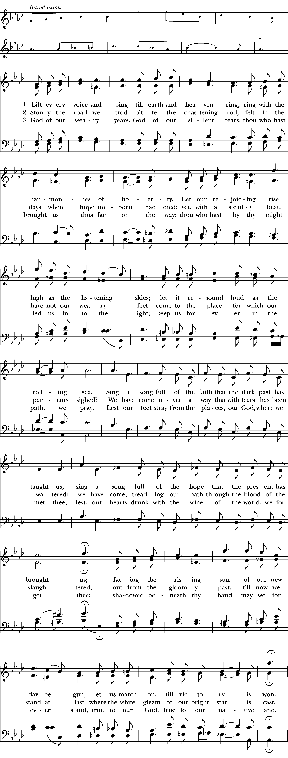


Altar flowers given in memory of Myrtle Kirkner
By Joe and Pat Kirkner

Please take a shift to hang out with the coolest kids in town, the CYI Service Corps workers. We need two adults in the church to take part of this important program. See the sign up at coffee hour. You must have your safe church training and clearances to take part. Let Rev. Kristen or Liz Hulse know.

Pictures wanted! Do you have pictures of Trinity’s members through the years? We’d like to start a display of our beloved members, showing our good times, prayers and diversity! Email them to Kristen at Kristen.ostendorf77@gmail.com or bring in hard copies so she can scan them. This is an on-going project.

Regular CYWA food bank commitment: See Kent N. if you would like to be part of our small but regular volunteer crew every other Thursday at the CYWA.

WANT PRAYER? Our prayer chain is ready! Place your request in the basket using the form on the credenza by the baptismal font. Give as little or as much information as you want: It is confidential.

IMPORTANT OFFICE UPDATE: We will automatically produce a giving statement for tax purposes for pledgers. However, if you give and want a statement and did not fill out a pledge card, please let us know! We are happy to provide one! Questions? Talk with Minnie Kirwin, treasurer, or Chris Haak, senior warden.

Step/Sanctuary Sit and Tide Over Pantry: Did you know we need about 200 items a week for our tide over pantry? Can you help re-stock or sit in the sanctuary to meet the neighbors? It’s easy, and a great way to serve our community. Ongoing needs: Items for Tide Over Pantry (shelf stable “complete” meals, shelf stable milk, bread, PB&J, cereal, canned meats and fish, hygiene items); clothes washing from our basement stock.

Upcoming Trinity Dates: Mark your calendars!

TODAY, June 28: St. Cyril’s Day – The Rev. Elisa King from St. Paul’s AME to preach. Bring a potluck dish to share! Sign up at coffee hour. Last Sunday for choir for the summer.
Thursday: Healing service on Zoom, noon.

SAVE THE DATES
July 5: Special Guest Preacher, the Ven. Phillip Geliebter, archdeacon of the Diocese of Pennsylvania
July 12, 4-6 p.m.: Community Dinner, in cooperation with St. Anne’s Episcopal Church (Abington) and Episcopal Legal Services. Free dinner for the community, with legal clinic. Concludes with evening prayer.
July 15, 6-8 p.m.: Safe Church in person training at St. Francis-in-the-Fields, Malvern, led by Rev. Kristen. Come at 5 p.m. if you need help with clearances. Sign up using link in email.
July 18: Annual Chicken BBQ fundraiser, with prep day on July 17. Join the fun for this vital fundraiser! See Pat Kirkner for more details!
Sept. 20: Rally Day! Details in the works

Please pray for those on our parish prayer list.
Violet Armstead, Angie Ashe, Bob Austin, Molly Baldwin, Marsha Barley, Bill Besecker, Violet Cole Marie Hyacinthe Bribal, Anthony Brogan, Walter Bryant, Lesley Cassidy, Millie Connor, Andrea Dudle, Ellie, Charles Emmett, Diane Evans, Marshall Evans, Morris Ferguson, Karen Fisher, Cassie Foreman, Kyla Foreman, Jacob Furlong, Ken Furlong, Phillip Geliebter, Bianca Giannotti, Linda Graber, Samantha Griggs, Susan Hanft, Scott Hansberry, Esther Harvey, Pat Hendricks, Matt Hess, Danyell Jackson, Henry James, Jennifer Jenkins, John and Lindsay, Justin, Kevin Kendig, Lisa Kivett, Sye Lamar, Melanie Lifer, Olivia Lyons, Joseph Manni, Robin McAllister, Paige McLean, Kevin McGloon, Brian Miller, Tracy Mulligan, Bruce Murray, Adam Nolt, Jessica Nupponen, Barbara Oxenreider, Steve Padosh, Stan Pernsley, April Phillips, Ben Phillips, Louise Poles, Lynn Pullman, Arlene Purnsley, Karen Ragland, Michael Rayner, Jacob Rockoff, Thomas Shanley, Barb Smelter, John Smelter, Stephen Smelter, Stephanie, Becky Swaggart, Sean, Dihona Talton and children, Bill Terry, Mike Tisbe, Catherine Thompson, Todd, Trinity, Vicki Romberger, Norman Walters, Cyndi Walters, Isaac Warnick, Sally Warren, Paul Wayne, Mary Nell Weiss, Chanel Wiest, Brendan Willauer,
Ruby Williams

And please pray for our first responders and those who serve in the military Police: Lt Lori and Jeff Kistle, Military: Skylar Dantzler, MAJ Alex Deets, PO William Dowling, 1st LT Frank Furman, Jr., J. Andrew Hinkle, SMSgt Rewa Miller, Sgt Kaleel Pernsley, Specialist Jason Sage, COL Jeremy Smith, CMDR Michael Sracic MD, SPC John Starrett

EPISCOPAL CHURCH OF THE TRINITY
323 East Lincoln Highway
Coatesville, Pennsylvania 19320
610-384-4771
Office Email: Trinitycoates@aol.com
Website: www.trinitycoatesville.org

Rev. Kristen’s hours
Sunday-Thursday
Friday- Sabbath

Office closed on Friday.
Please reach out to Liz Hulse via the church phone or her email below for hall rentals.

You’re always welcome to stop by, but please call or text ahead to make sure Rev. Kristen or someone is there.

Priest in Charge: The Rev. Kristen Ostendorf 908-489-1452 (kristen.ostendorf77@gmail.com)
Organist and Choirmaster: Rachel Lee Anemone
Community Engagement Coordinator: Liz Hulse (liztrinity323@gmail.com)

LEADERSHIP TEAM and VESTRY
Sr. Warden: Chris Haak
Treasurer: Minnie Kirwin
Jr. Warden: Joe Lee

Pat Bush, Al Carey, Violet Cole, Bill Gray, Stacey Heston,
Greg Kinsch, Joseph Kirkner, Kent Nation, Vic Shanley,
Betty Sullivan, Michael Thompson

